To populate in **Recordset**

|  |  |
| --- | --- |
|  |  |

Another option is using an **Execute SQL Task**

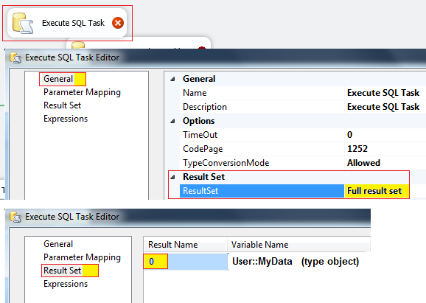

Configure the **Recordset, the most important one is to set to a variable type object named MyData**

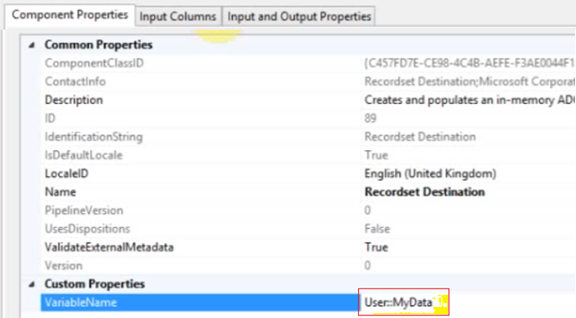

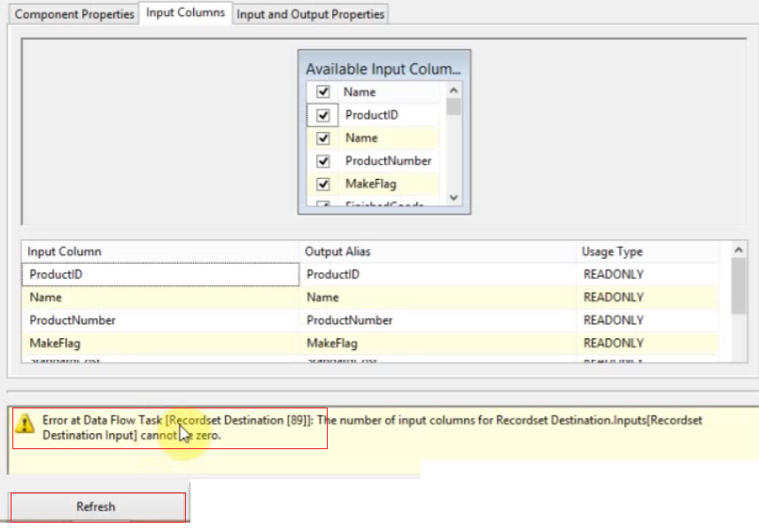

To avoid the error **click Refresh**

To read the variable, you can use a script or a for each

In the foreach use

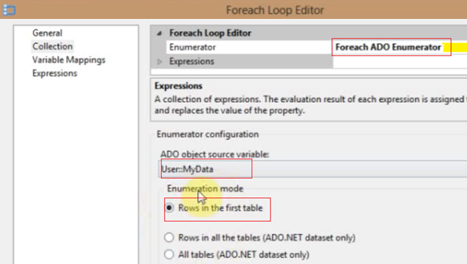

The object variable **MyData** is set, now in the Variable Mapping we set a local variable **strShift** to take the second column of the recordset **MyData**. It is taken the second field because the index is **1.** So we are going to scroll only the second field

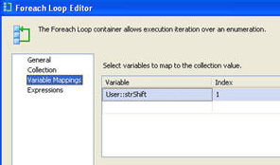

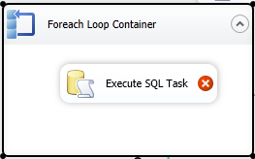

Use the variable **strShift** as input to the **Execute SQL Task**